**Sprint 1 Mid-Point Progress Reporting**

**Top Deal Auto Website**

**Company:** Top Deal Auto Melbourne, Australia

**Software:** Car Selling Website

**Team name:** Prestige K/DA

**Team Members:**

| **Name** | **ID** | **Roles** |
| --- | --- | --- |
| Pham Duc Linh | 103792371 | Product Owner - BA |
| Pham Anh Vu | 103806447 | Solutions, IT Architect |
| Nguyen Thanh Dat | 103804881 | Project Manager - Scrum Master |
| Tran Tuan Nam | 103792643 | Lead Developer (BE) |
| Phung Xuan Tung | 103792054 | Lead Developer (FE) |

**Tutorial class:** Fri 1:00 PM DT7.2

**Tutor’s Name:** Dr. Pham Thi Kim Dzung

**Task board Reporting**

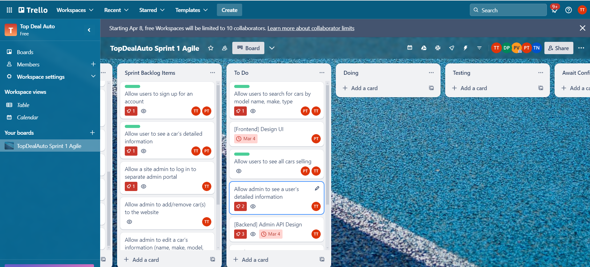

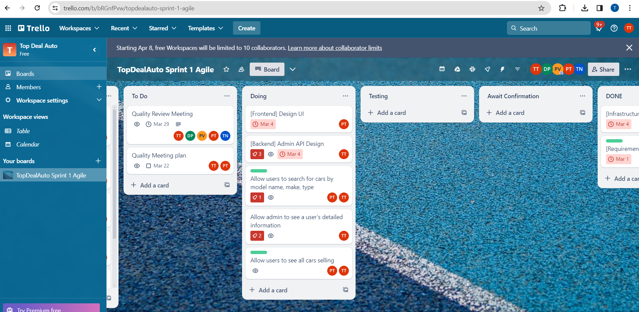

**Day 1**

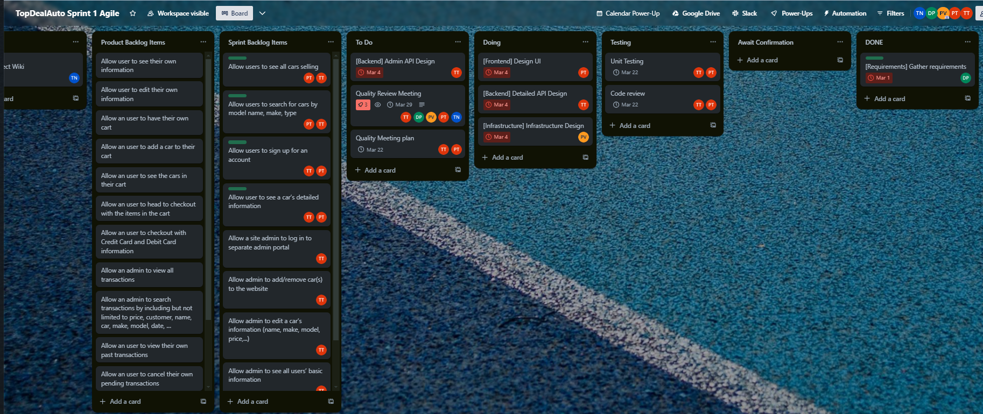

**Day 2**

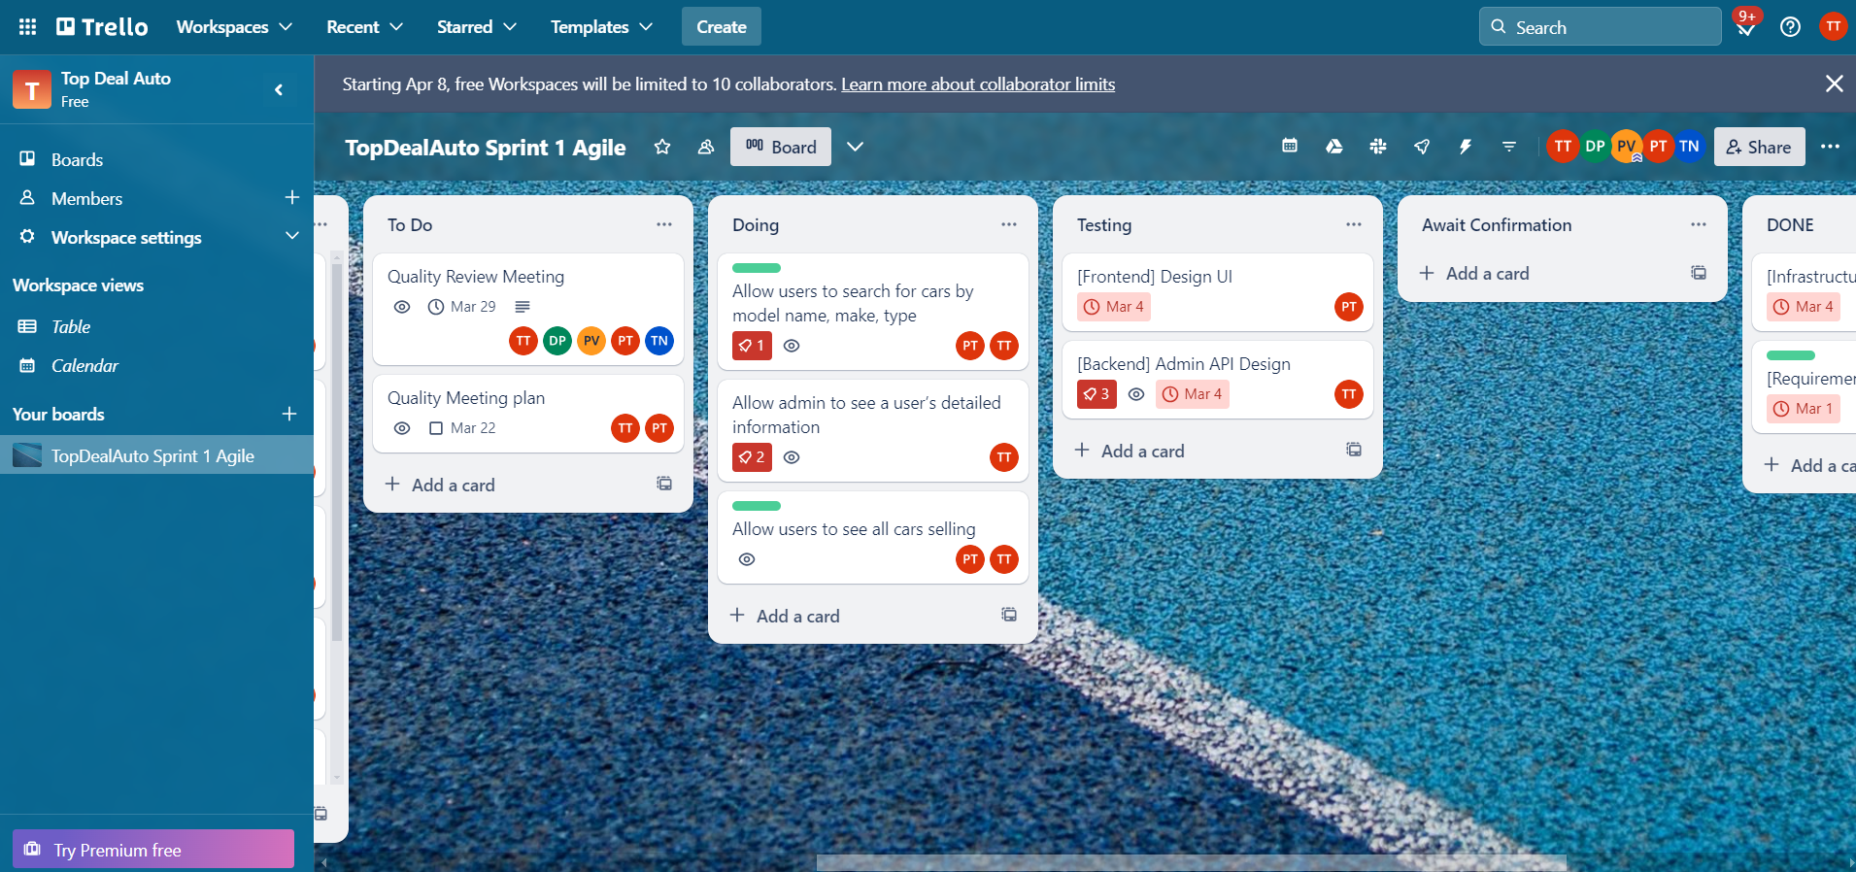

**Day 3**

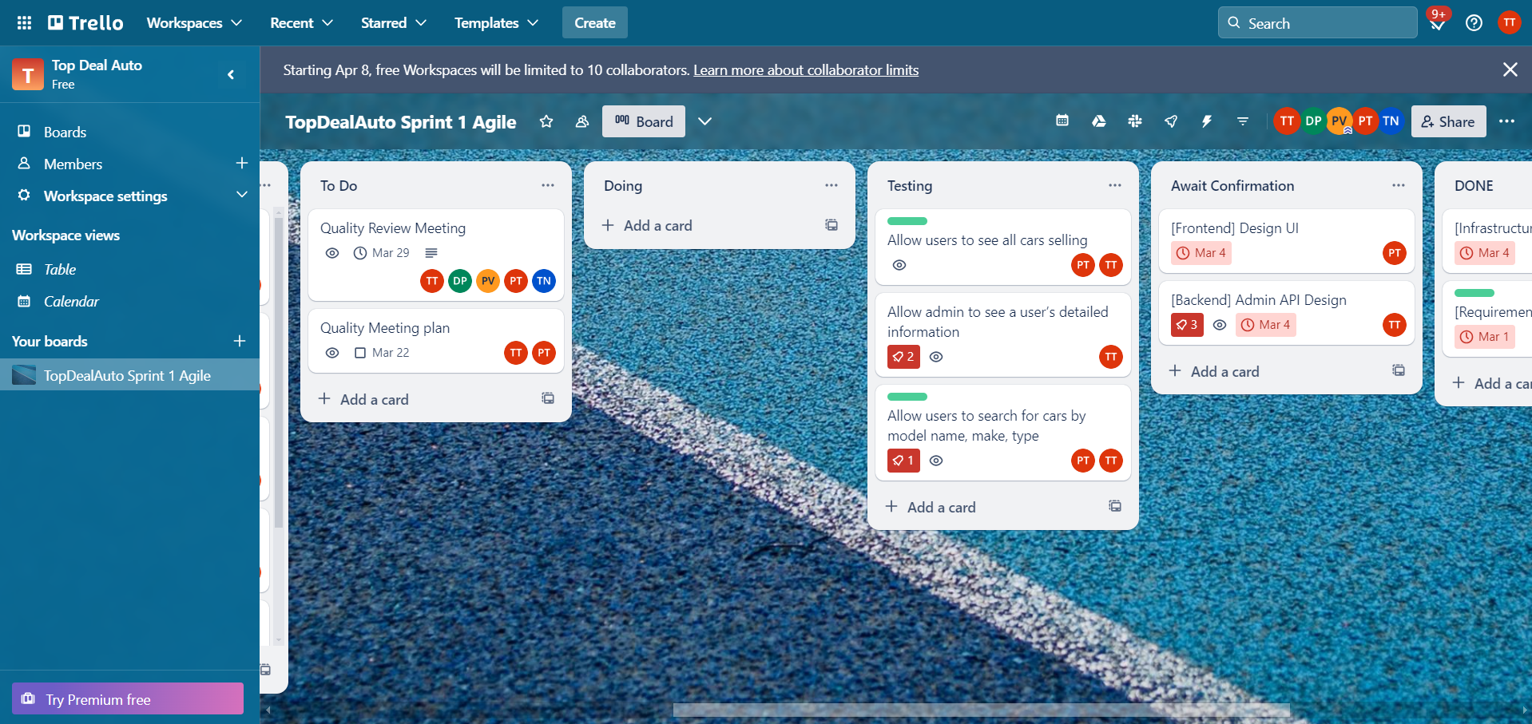

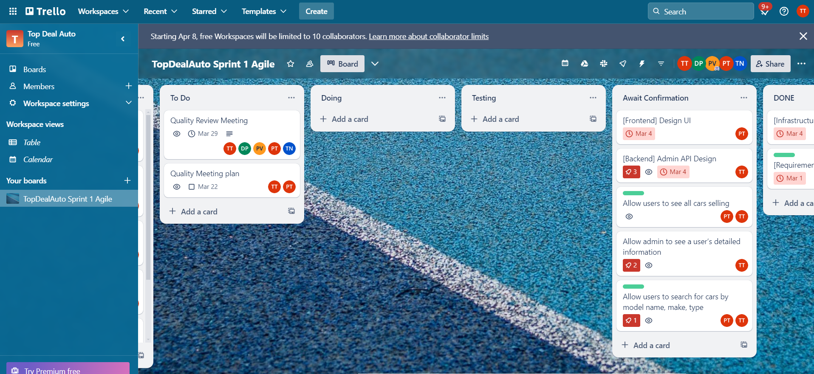

**Day 4**

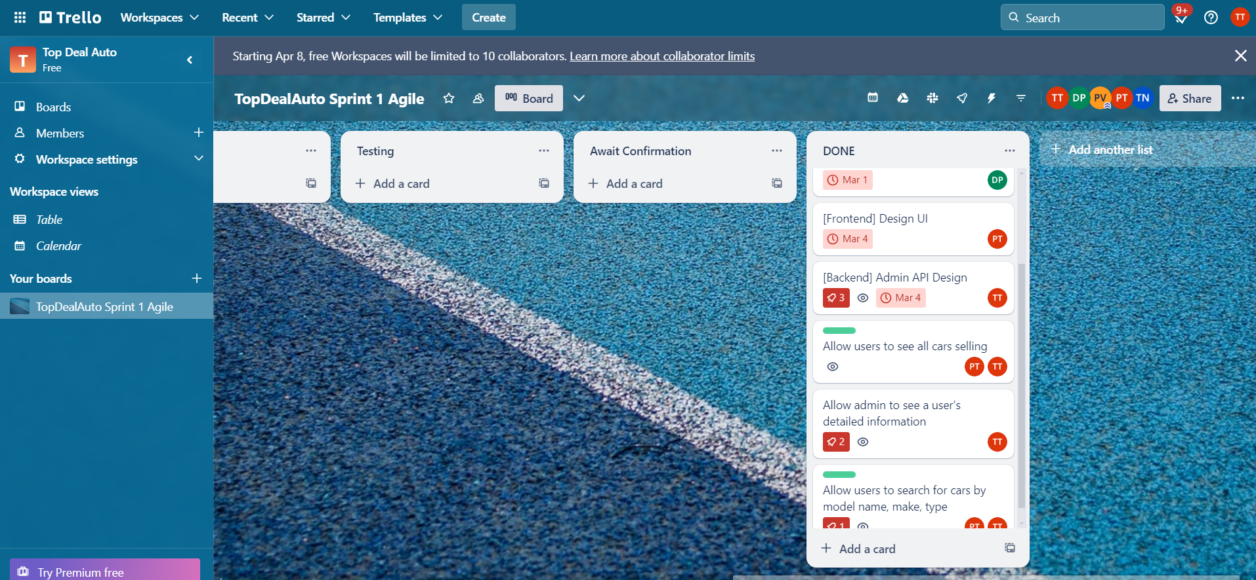

**Day 5**

**Burn-down Chart Reporting**

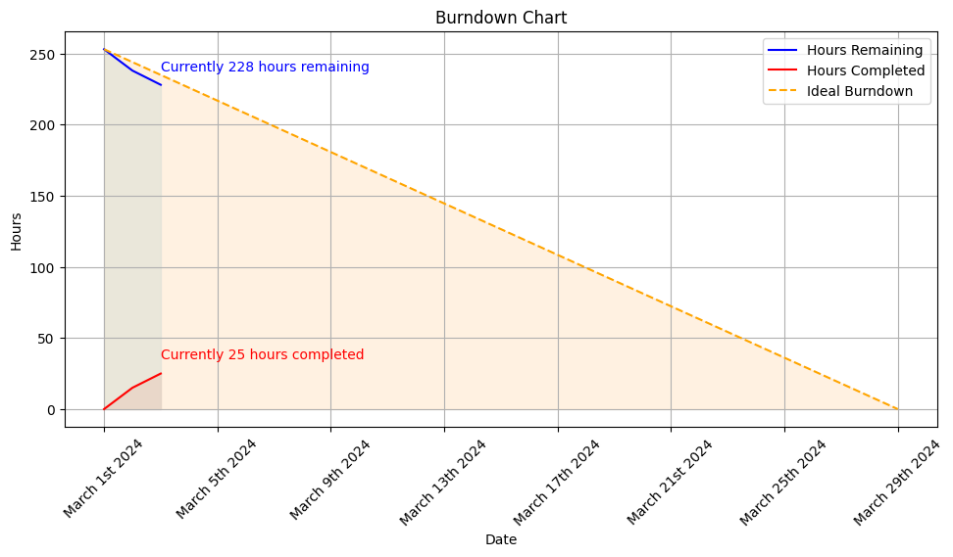

**Day 1**

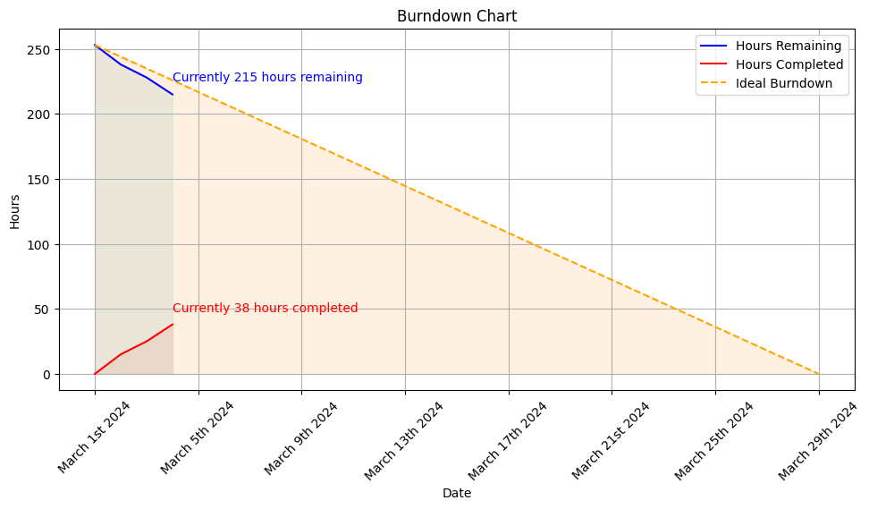

**Day 2**

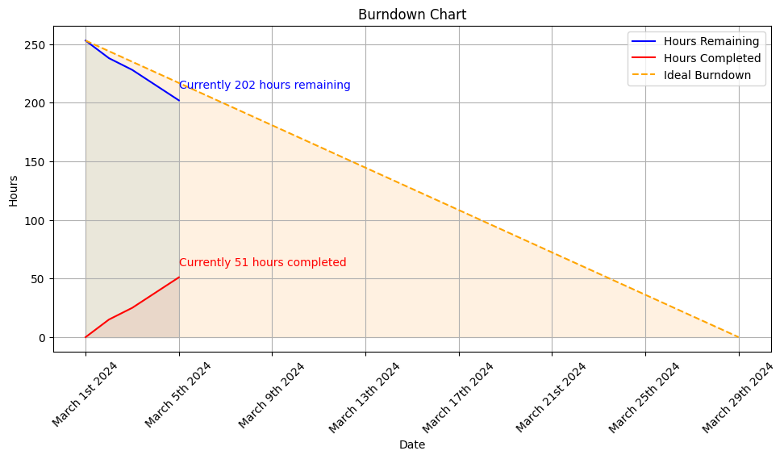

**Day 3**

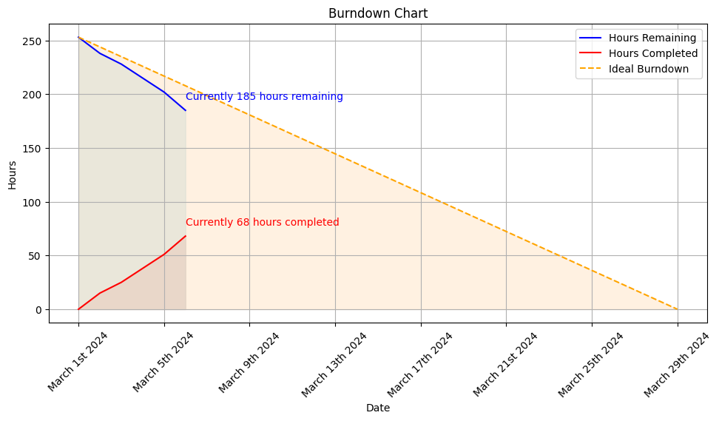

**Day 4**

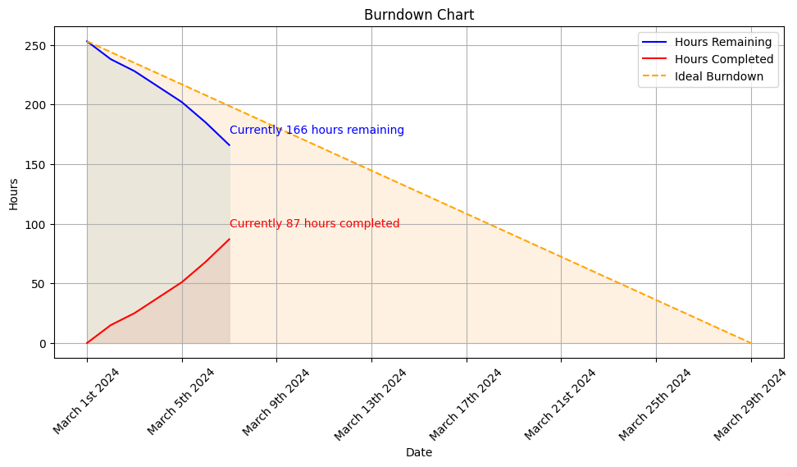

**Day 5**

**Project Repository Reporting**

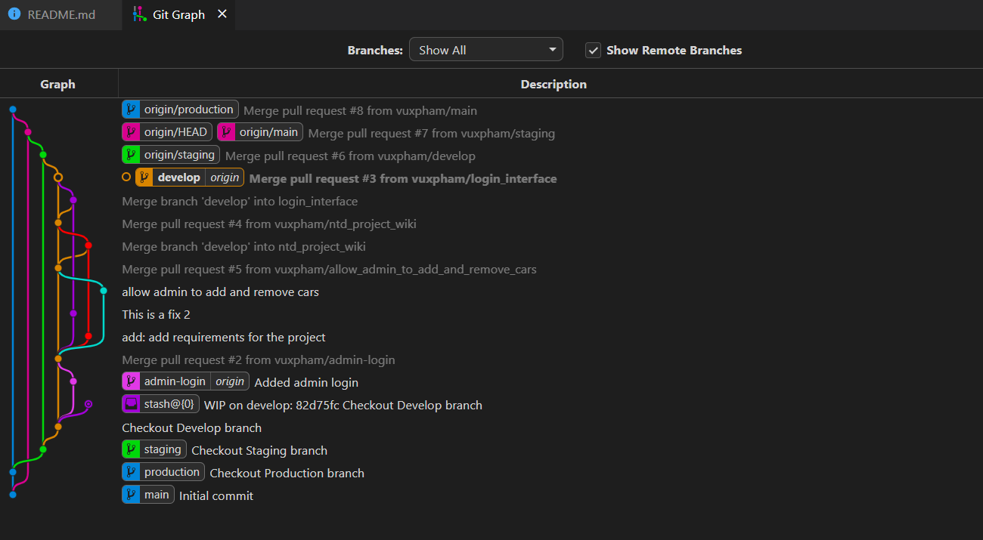

**Day 1 (Initial BE features)**

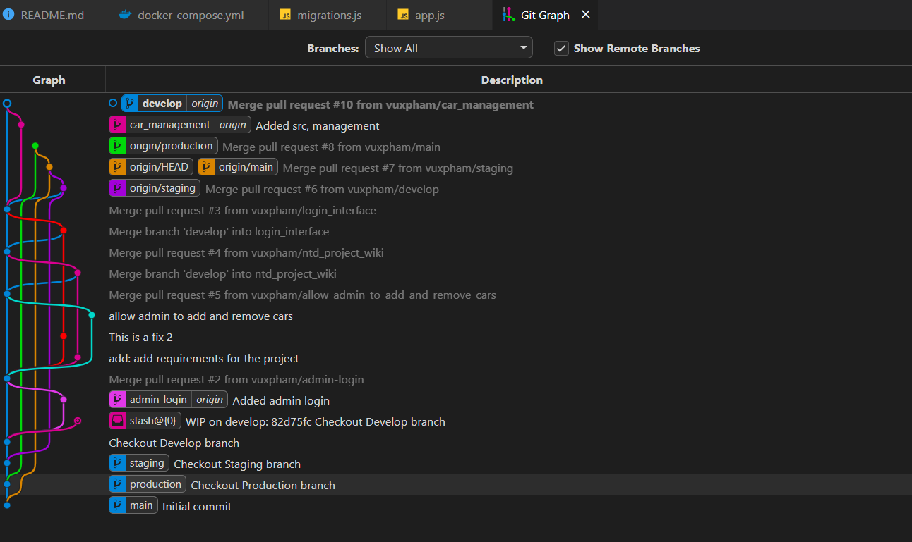

**Day 2 (Extra fixes for BE)**

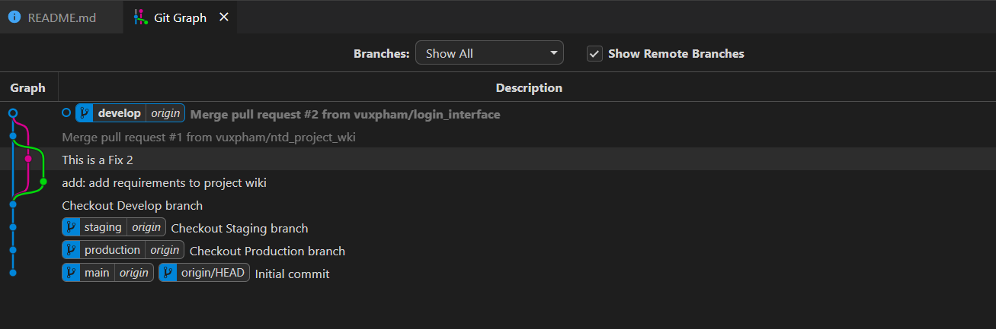

**Day 3 (Front End template commit)**

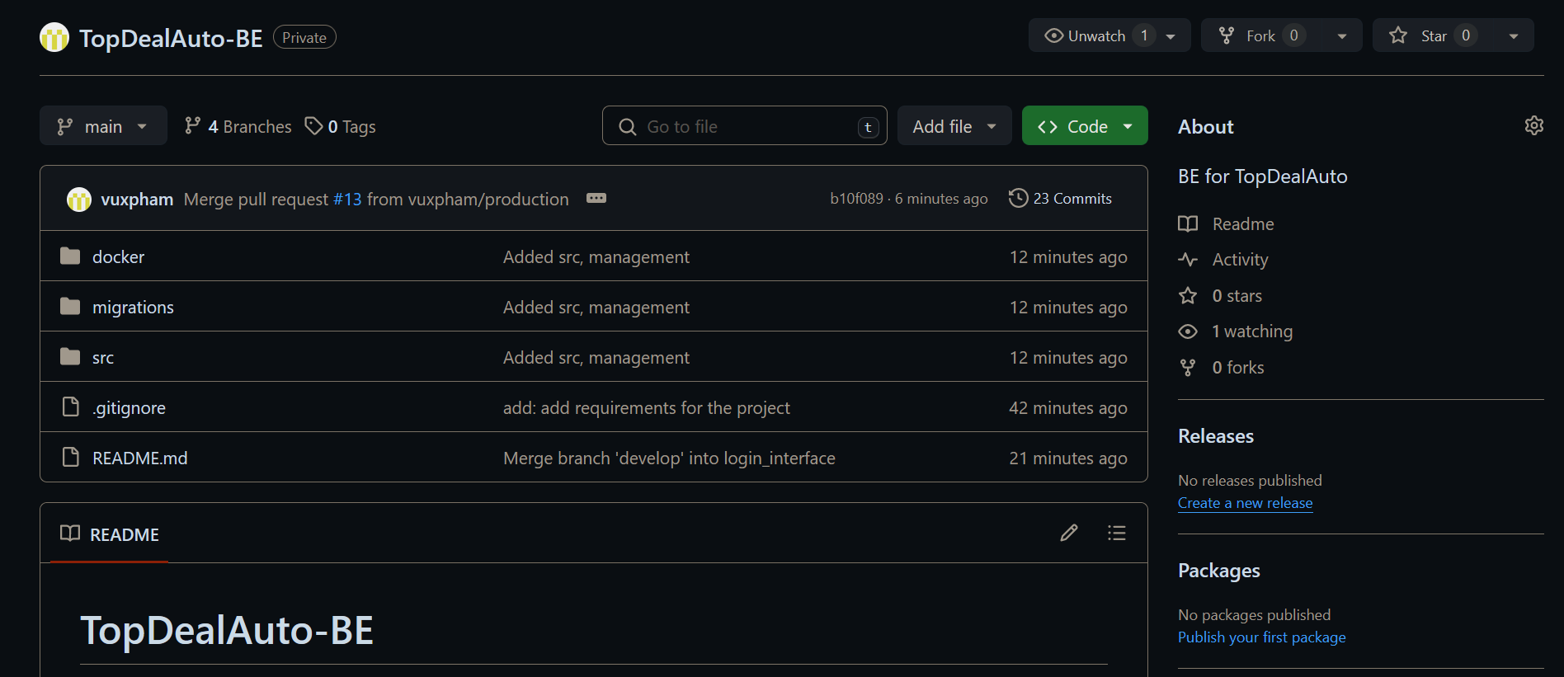

**Day 4 (Added source and docker template to BE)**

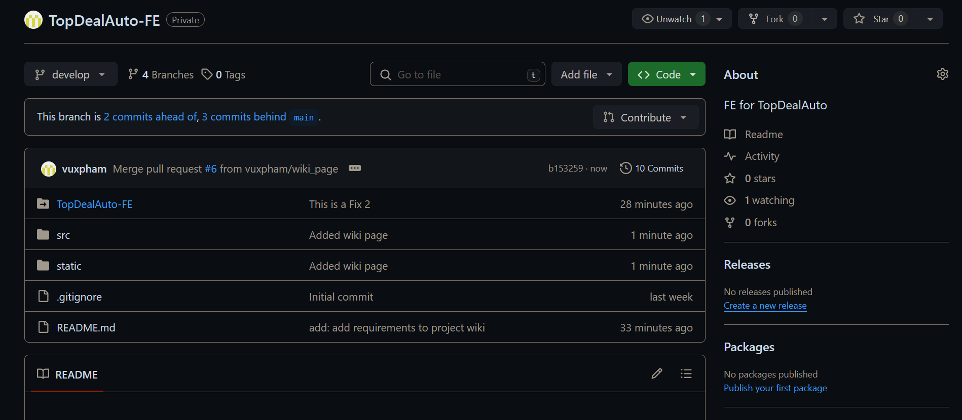

**Day 5 (Added wiki page to FE)**

**Group’s minutes of daily stand-up meeting V**

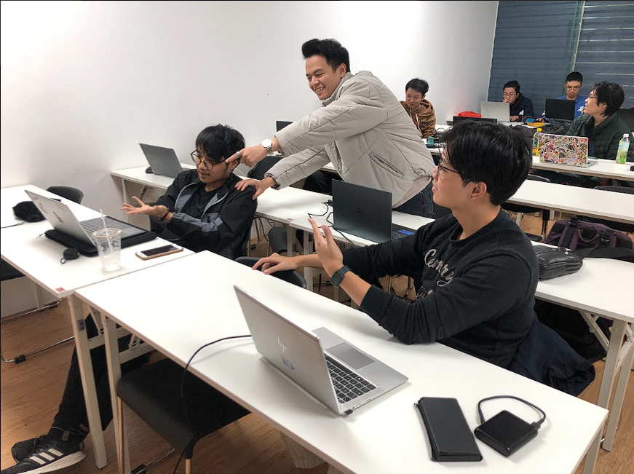

**Day 1**

